

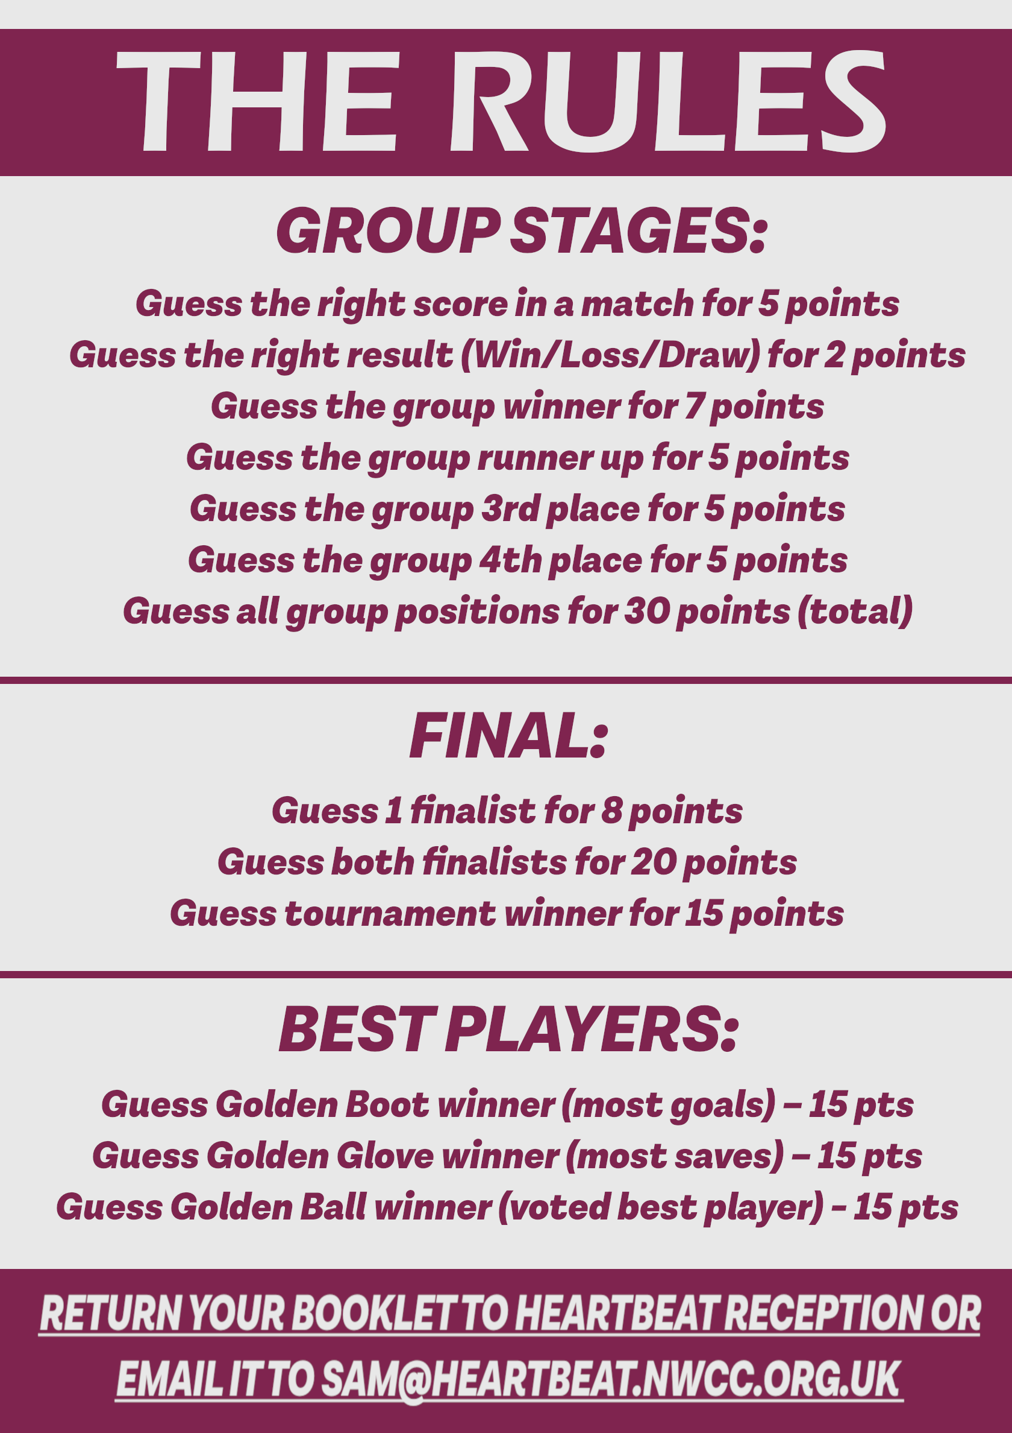

X

X

X

X

X

X

X

X

X

X

X

X

X

X

X

X

X

X

X

X

X

X

X

X



X

X

X

X

X

X

X

X

X

X

X

X

X

X

X

X

X

X

X

X

X

X

X

X

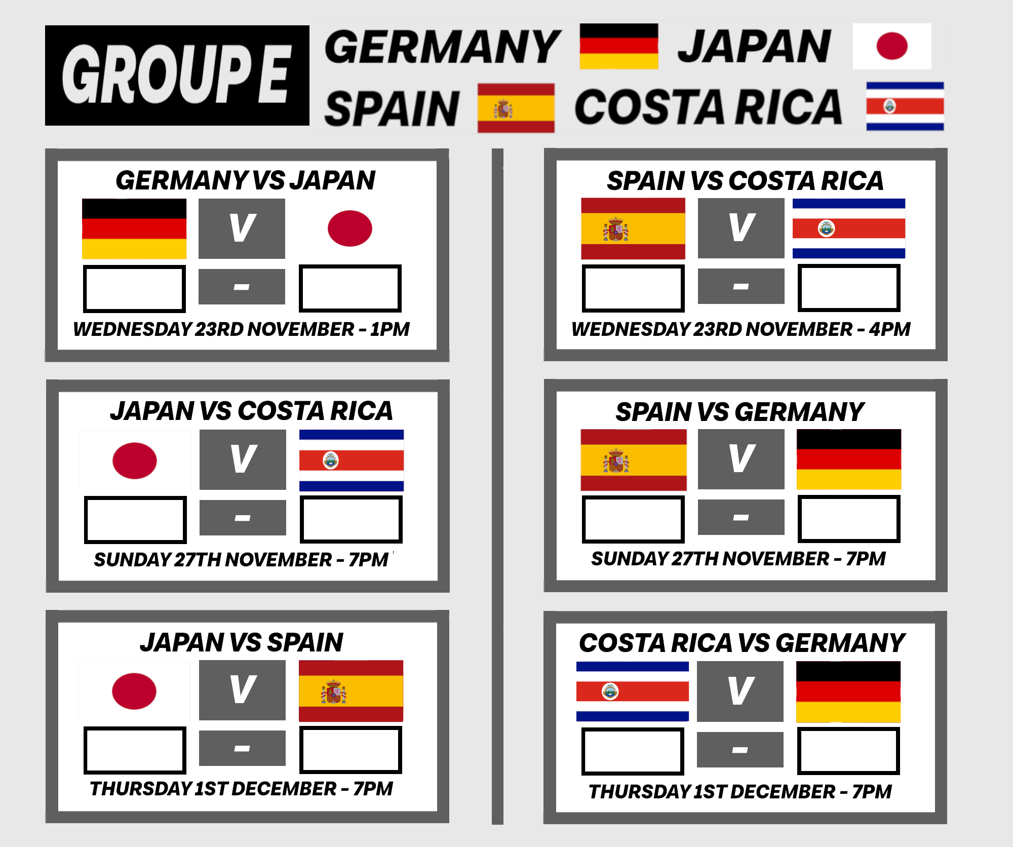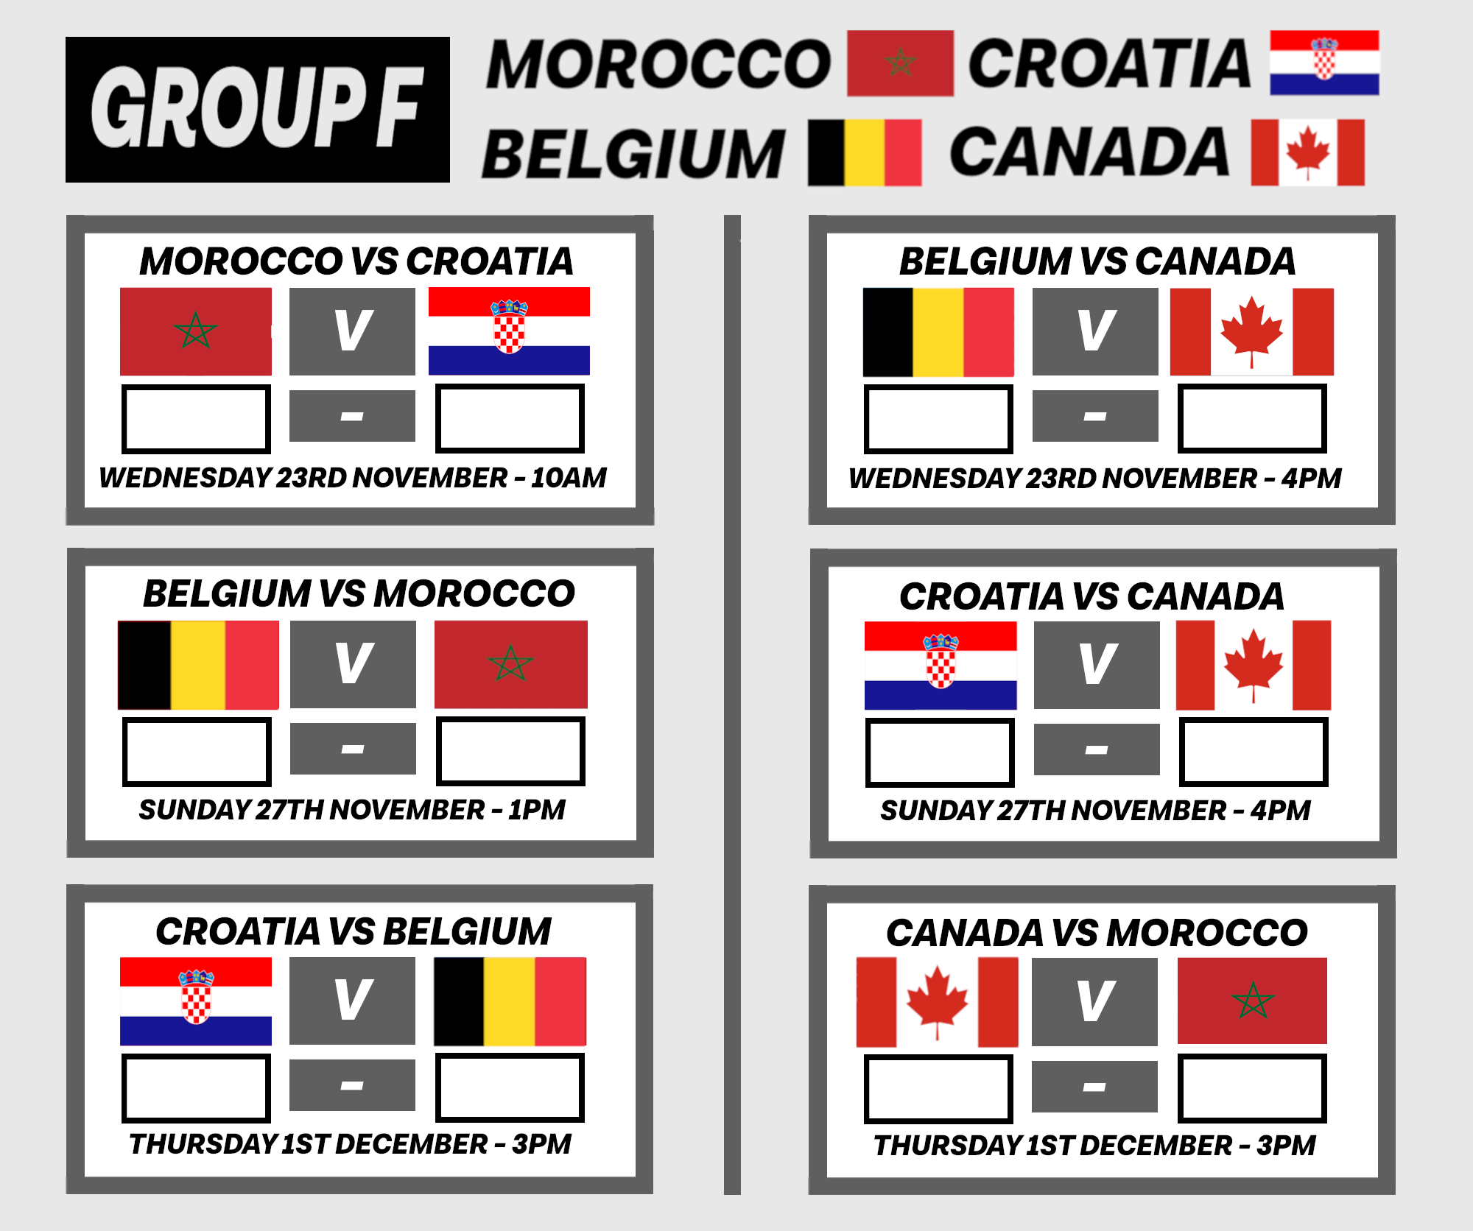

X

X

X

X

X

X

X

X

X

X

X

X

X

X

X

X

X

X

X

X

X

X

X

X

X

X

X

X

X

X

X

X

X

X

X

X

X

X

X

X

X

X

X

X

X

X

X

X

X

X

X

X

X

X

X

X

X

X

X

X

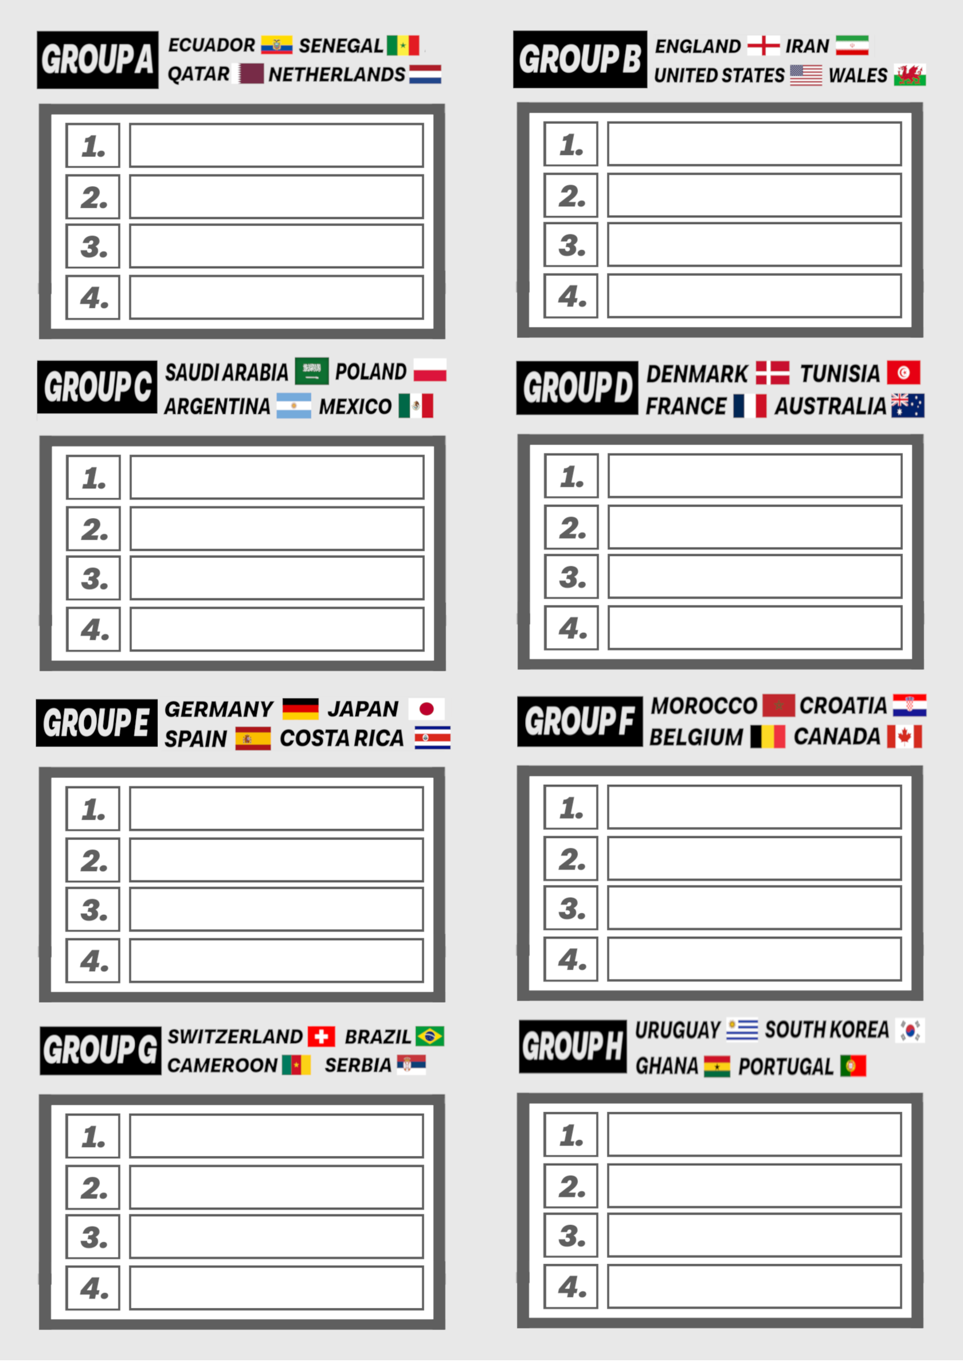

X

X

X

X

X

X

X

X

X

X

X

X

X

X

X

X

X

X

X

X

X

X

X

X

X

X

X

X

X

X

X

X

X

X

X

X

X

X





X

X

X